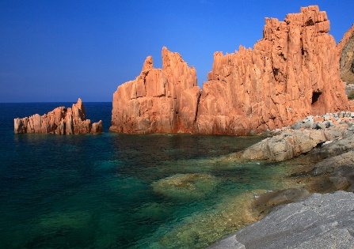

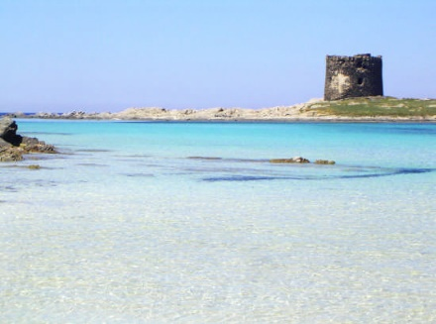

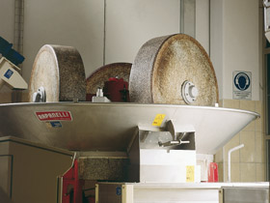

**SECCHI OIL MILL**

The Secchi oil mill was born in 1930 and it handed down its oil production for almost 100 years. Thanks to a careful collection and selection, the extra virgin olive oil produced is healthy and light, with very low acidity and a fruity taste.

The oil is produced with the molazze in granite stone for squeezing and then the oil is extract from mixing by a delicate system.

**Food&Wine Itinerary Stintino First day**

Details:

Start: 10:30AM

Trip 46 km to Sassari

Arrival: 11:00AM

Duration: 60min.



**“LA LEPANTO” RESTAURANT**

IThe La Lepanto is one of the most renowned restaurants in Alghero especially for the queen of all cuisines: the lobster. Here it is prepared in Catalonian-way and is one of the best local dishes. Lobster is also the typical dish of the whole town of Alghero.

At the restaurant La Lepanto, beyond the lobster, you can enjoy excellent appetizers of fish, prawns, cuttlefish, all accompanied by an excellent Vermentino di Sardegna

Dettagli

Partenza: 16.30

Viaggio: 24 km verso Otranto

Arrivo: 17:00

Durta: 2h 30m

Surrounded by a beautiful landscape, you will enter in direct contact with the uncontaminated territory of Sardinia and by savoring the flavors you'll discover how the relationship between man and nature can lead to a mutual and unforgettable excitement.

Details:

Start: 12:00AM

Trip:35 km to Alghero

Duration: 90m

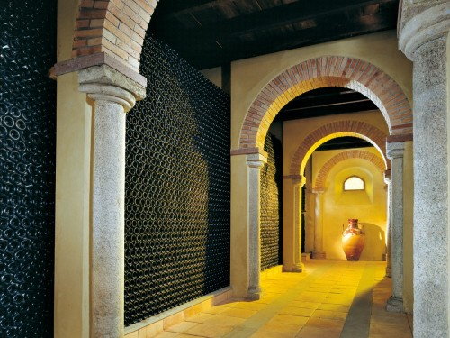

**SELLE AND MOSCA WINERY**

After a walk in the Alghero promenade, you leave for the visit and tastings to the famous Sella & Mosca wineries founded in 1899 after the ground remediation. Now it has 550 hectares of vineyards and produces a wide range of wines, such as Alghero Torbato and those provided in the specification Carignano del Sulcis, Cannonau, Alghero DOC.

The visit includes a guided tour in the most representative structures such as cellars, built in 1903 and 1922, cellar for the traditional reserve cannonau aging, the historical exhibition on the noble house of Pes of Villamarina, in addition to the company's history museum. All include a tasting of various wines, accompanied by tastings of typical products.

Details

Start: 2PM

Trip: 11 km to Località i Piani

Duration: 90m

**GENERAL INFO:**

**Total duration: 8h**

**Start: 10:30 Stintino**

**Total km by car: 138km – 2h**